Digital Communication Lab-7

Name – Nisarg Patel

ID - 202101216

- From Manual kit 2807, perform experiments 1 to 6 on Amplitude shift keying (ASK). The page numbers for the same are given in the table of contents. You need to follow the procedures given in the manual and observe the output as suggested in the observations.

Ex1:-
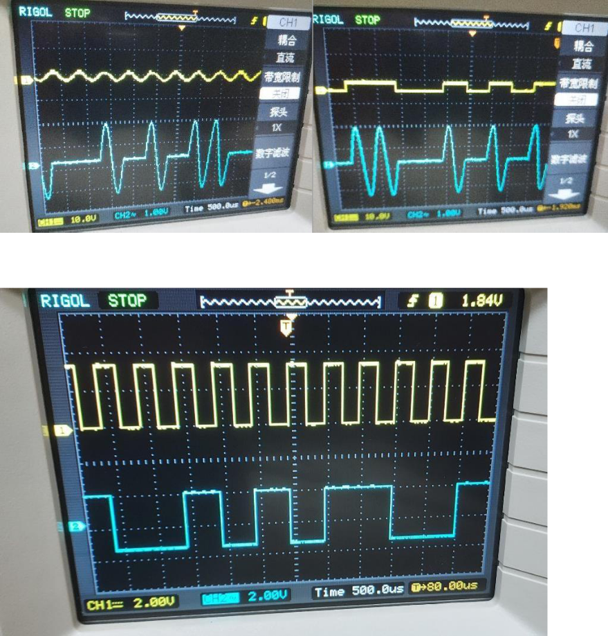
Ex2:-
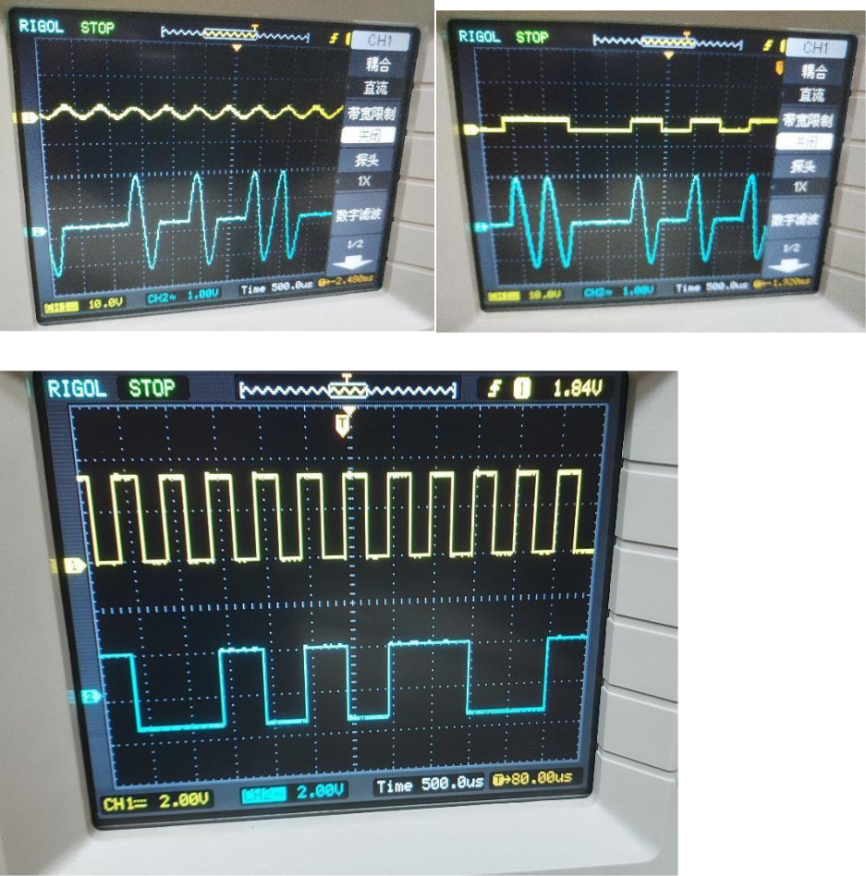

Ex3:-
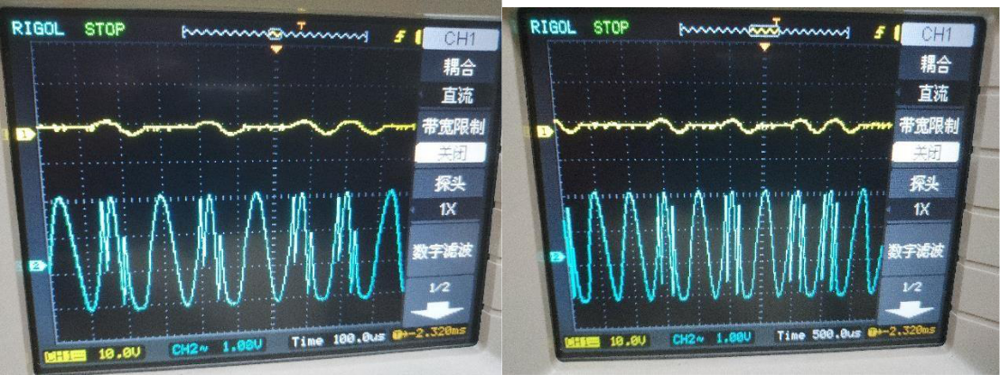
Ex4:-
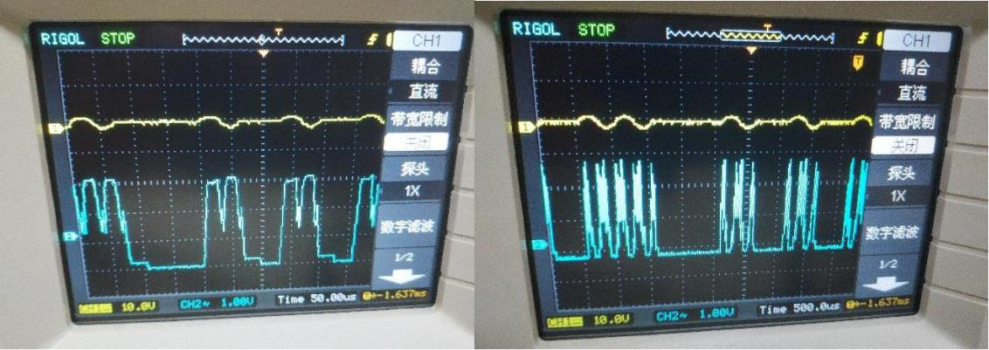

Ex5:-
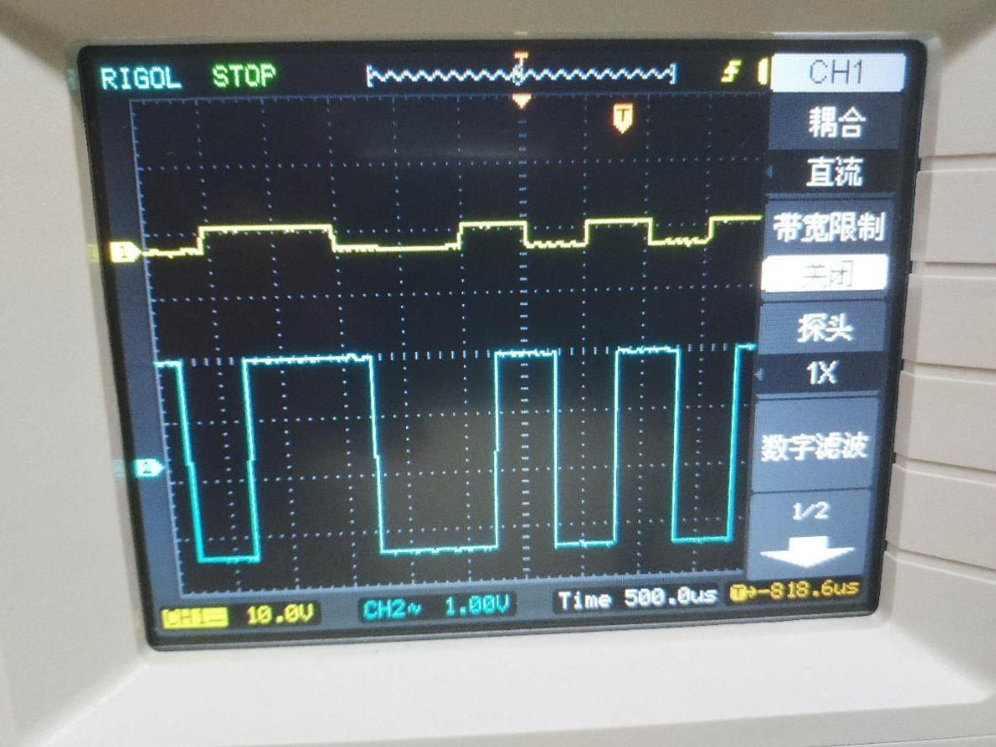
Ex6:-
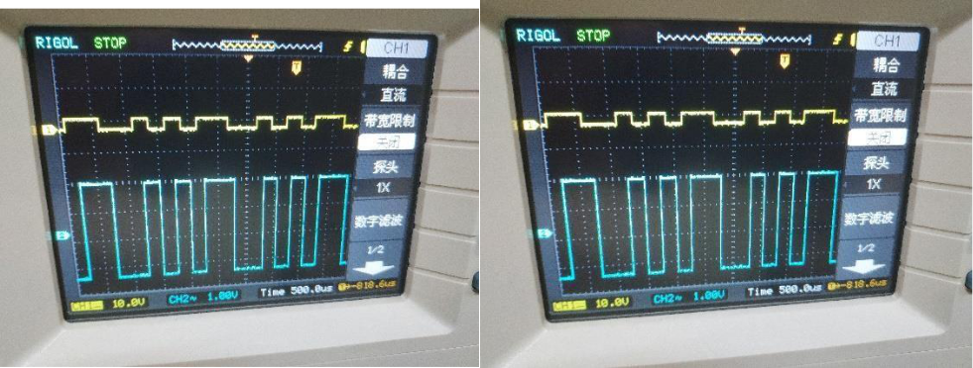

  - From [2], go through “Signal correlator” from section 5.2, solve illustrative problems 5.1 and 5.2. Then, reproduce the MATLAB script for illustrative problem 5.2. Thereafter, from the problems at the end of the chapter, solve problem 5.3.

Illustrative Problem 5.2:- Matlab code:-

- MATLAB script for Illustrative Problem 5.2

- Initialization:

- Signal amplitude l = 0:K;

- Defining signal waveforms: s_0 = A * ones(1, K);
s_1 = [A * ones(1, K/2), -A * ones(1, K/2)];

- Initialize output signals:r_0 =
zeros(1, K);

r_1 = zeros(1, K);

- Case 1: noise-N(0, 0)noise = randn(1, K);

- Sub-case s = s_0:

s = s_0;
r = s + noise; % received signal

for n = 1:K

r_0(n) = sum(r(1:n) .* s_0(1:n));
r_1(n) = sum(r(1:n) .* s_1(1:n));

end

- Plotting the results: subplot(3, 2, 1)
plot(0:K, [0, r_0], '-', 0:K, [0, r_1], '--')

set(gca, 'XTickLabel', {'0', '5Tb', '10Tb', '15Tb', '20Tb'})
axis([0, 20, -5, 30])

xlabel('(a) \sigmaA2= 0 & S_{0} is transmitted', 'fontsize', 10)

- Sub-case s = s_1: s = s_1;

r = s + noise; % received signal

for n = 1:K

r_0(n) = sum(r(1:n) .* s_0(1:n));
r_1(n) = sum(r(1:n) .* s_1(1:n));

end

- Plotting the results: subplot(3, 2, 2)
plot(0:K, [0, r_0], '-', 0:K, [0, r_1], '--')

set(gca, 'XTickLabel', {'0', '5Tb', '10Tb', '15Tb', '20Tb'})axis([0, 20, -5, 30]) xlabel('(b) \sigmaA2= 0 & S_{1} is transmitted', 'fontsize', 10)

- Case 2: noise-N(0, 0.1) noise =
0.1 * randn(1, K);

- Sub-case s = s_0: s = s_0;

r = s + noise; % received signal

for n = 1:K

r_0(n) = sum(r(1:n) .* s_0(1:n));
r_1(n) = sum(r(1:n) .* s_1(1:n));

end

- Plotting the results: subplot(3, 2, 3)
plot(0:K, [0, r_0], '-', 0:K, [0, r_1], '--')

set(gca, 'XTickLabel', {'0', '5Tb', '10Tb', '15Tb', '20Tb'})axis([0, 20, -5, 30]) xlabel('(c) \sigmaA2= 0.1 & S_{0} is transmitted', 'fontsize', 10)

- Sub-case s = s_1:

s = s_1;
r = s + noise; % received signal

for n = 1:K

r_0(n) = sum(r(1:n) .* s_0(1:n));
r_1(n) = sum(r(1:n) .* s_1(1:n));

end

- Plotting the results: subplot(3, 2, 4)
plot(0:K, [0, r_0], '-', 0:K, [0, r_1], '--')

set(gca, 'XTickLabel', {'0', '5Tb', '10Tb', '15Tb', '20Tb'})axis([0, 20, -5, 30]) xlabel('(d) \sigmaA2= 0.1 & S_{1} is transmitted', 'fontsize', 10)

- Case 3: noise-N(0, 1)noise =
randn(1, K);

- Sub-case s = s_0:s = s_0;
r = s + noise; % received signal

for n = 1:K

r_0(n) = sum(r(1:n) .* s_0(1:n));
r_1(n) = sum(r(1:n) .* s_1(1:n));

end

- Plotting the results: subplot(3, 2, 5)
plot(0:K, [0, r_0], '-', 0:K, [0, r_1], '--')

set(gca, 'XTickLabel', {'0', '5Tb', '10Tb', '15Tb', '20Tb'})axis([0, 20, -5, 30]) xlabel('(e) \sigmaA2= 1 & S_{0} is transmitted', 'fontsize', 10)

- Sub-case s = s_1:

s = s_1;
r = s + noise; % received signal

for n = 1:K

r_0(n) = sum(r(1:n) .* s_0(1:n));
r_1(n) = sum(r(1:n) .* s_1(1:n));

end

- Plotting the results: subplot(3, 2, 6)
plot(0:K, [0, r_0], '-', 0:K, [0, r_1], '--')

set(gca, 'XTickLabel', {'0', '5Tb', '10Tb', '15Tb', '20Tb'})axis([0, 20, -5, 30]) xlabel('(f) \sigmaA2= 1 & S_{1} is transmitted', 'fontsize', 10)

- Display the plots

subtitle('Signal Detection Scenarios');

O/p:-
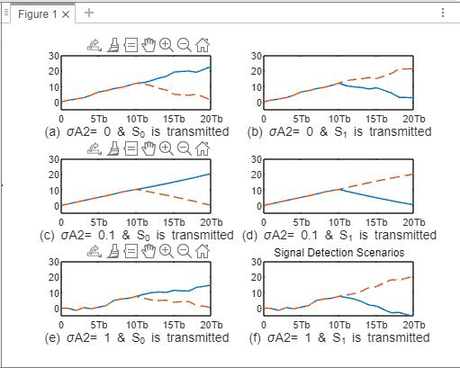
Problem 5.3

- MATLAB script for Illustrative Problem 5.2

- Initialization:

- Signal amplitude l = 0:K;

- Defining signal waveforms: s_0 = A * ones(1, K);
s_1 = [A * ones(1, K/2), -A * ones(1, K/2)];

- Initialize output signals:
r_0 = zeros(1, K);r_1 =
zeros(1, K);

% Noise variances:

noise_variances = [0.1, 1, 3];

for var_idx = 1:length(noise_variances)

% Generate noise with different variances
noise = sqrt(noise_variances(var_idx)) * randn(1, K);

- Sub-case s = s_0: s = s_0;

r = s + noise; % received signal

for n = 1:K

r_0(n) = sum(r(1:n) .* s_0(1:n));

r_1(n) = sum(r(1:n) .* s_1(1:n));
end

- Plotting the results: subplot(3, 3, var_idx)
plot(0:K, [0, r_0], '-', 0:K, [0, r_1], '--')
set(gca, 'XTickLabel', {'0', '5Tb', '10Tb', '15Tb', '20Tb'})axis([0, 20, -5, 30])

title(['\sigma^2 = ' num2str(noise_variances(var_idx))], 'fontsize', 10)if var_idx == 1 ylabel('Output', 'fontsize', 10)
end

- Sub-case s = s_1:

s = s_1;
r = s + noise; % received signal

for n = 1:K

r_0(n) = sum(r(1:n) .* s_0(1:n));

r_1(n) = sum(r(1:n) .* s_1(1:n));
end

- Plotting the results: subplot(3, 3, var_idx + 3)
plot(0:K, [0, r_0], '-', 0:K, [0, r_1], '--')

set(gca, 'XTickLabel', {'0', '5Tb', '10Tb', '15Tb', '20Tb'})axis([0, 20, -5, 30]) if var_idx == 1

ylabel('Output', 'fontsize', 10)
end
end

% Display the plots

subtitle('Signal Detection Scenarios');
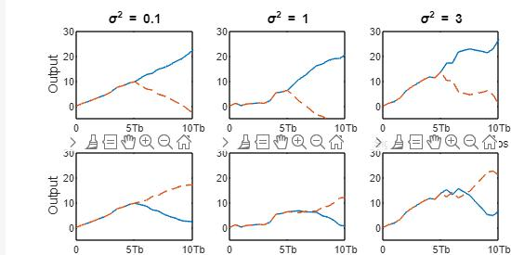

- From [2], go through “Matched filter” from sections 5.2, solve illustrative problems 5.3 and 5.4. Then, reproduce the MATLAB script for illustrative problem 5.4. Thereafter, from the problems at the end of the chapter, solve problem 5.4.

Illustrative Problem 5.4:-

- MATLAB script for Illustrative Problem 5.4.
- Initialization:

- Signal amplitude l = 0:K;

- Defining signal waveforms: s_0 = A * ones(1, K);
s_1 = [A * ones(1, K/2) -A * ones(1, K/2)];

- Initializing output signals: y_0 = zeros(1, K);

y_1 = zeros(1, K);
% Case 1: noise - N(0, 0)

noise = random('Normal', 0, 0, 1, K);

- Sub-case s = s_0: s = s_0;

y = s + noise; % received signal y_0 = conv(y, fliplr(s_0));

y_1 = conv(y, fliplr(s_1));

- Plotting the results:

subplot(3, 2, 1);

plot(l, [0 y_0(1:K)], '-k', l, [0 y_1(1:K)], '--k');

set(gca, 'XTickLabel', {'0', '5Tb', '10Tb', '15Tb', '20Tb'});axis([0 20 -30 30]); xlabel('(a) \sigma^2 = 0 & S_0 is transmitted', 'fontsize', 10);

- Sub-case s = s_1: s = s_1;

y = s + noise; % received signal y_0 = conv(y, fliplr(s_0));

y_1 = conv(y, fliplr(s_1));

- Plotting the results:

subplot(3, 2, 2);

plot(l, [0 y_0(1:K)], '-k', l, [0 y_1(1:K)], '--k');

set(gca, 'XTickLabel', {'0', '5Tb', '10Tb', '15Tb', '20Tb'});axis([0 20 -30 30]); xlabel('(b) \sigma^2 = 0 & S_1 is transmitted', 'fontsize', 10);

% Case 2: noise - N(0, 0.1)

noise = random('Normal', 0, 0.1, 1, K);

- Sub-case s = s_0: s = s_0;

y = s + noise; % received signal y_0 = conv(y, fliplr(s_0));

y_1 = conv(y, fliplr(s_1));

- Plotting the results:

subplot(3, 2, 3);

plot(l, [0 y_0(1:K)], '-k', l, [0 y_1(1:K)], '--k');

set(gca, 'XTickLabel', {'0', '5Tb', '10Tb', '15Tb', '20Tb'});axis([0 20 -30 30]); xlabel('(c) \sigma^2 = 0.1 & S_0 is transmitted', 'fontsize', 10);

- Sub-case s = s_1: s = s_1;

y = s + noise; % received signal y_0 = conv(y, fliplr(s_0));

y_1 = conv(y, fliplr(s_1));

- Plotting the results:

subplot(3, 2, 4);
plot(l, [0 y_0(1:K)], '-k', l, [0 y_1(1:K)], '--k');

set(gca, 'XTickLabel', {'0', '5Tb', '10Tb', '15Tb', '20Tb'});axis([0 20 -30 30]); xlabel('(d) \sigma^2 = 0.1 & S_1 is transmitted', 'fontsize', 10);

% Case 3: noise - N(0, 1)
noise = random('Normal', 0, 1, 1, K);

- Sub-case s = s_0: s = s_0;

y = s + noise; % received signal y_0 = conv(y, fliplr(s_0));

y_1 = conv(y, fliplr(s_1));

- Plotting the results:

subplot(3, 2, 5);

plot(l, [0 y_0(1:K)], '-k', l, [0 y_1(1:K)], '--k');

set(gca, 'XTickLabel', {'0', '5Tb', '10Tb', '15Tb', '20Tb'});axis([0 20 -30 30]); xlabel('(e) \sigma^2 = 1 & S_0 is transmitted', 'fontsize', 10);

- Sub-case s = s_1: s = s_1;

y = s + noise; % received signal y_0 = conv(y, fliplr(s_0));

y_1 = conv(y, fliplr(s_1));

- Plotting the results:

subplot(3, 2, 6);

plot(l, [0 y_0(1:K)], '-k', l, [0 y_1(1:K)], '--k');

set(gca, 'XTickLabel', {'0', '5Tb', '10Tb', '15Tb', '20Tb'});axis([0 20 -30 30]); xlabel('(f) \sigma^2 = 1 & S_1 is transmitted', 'fontsize', 10);
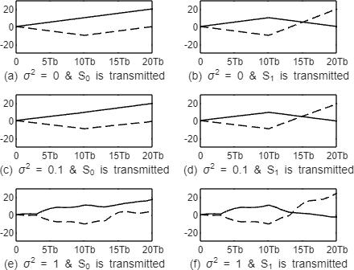

Problem 5.4:-

Matlab Code:-

- MATLAB script for Illustrative Problem 5.4.

- Initialization:

- Signal amplitude l = 0:K;

- Defining signal waveforms: s_0 = A * ones(1, K);
s_1 = [A * ones(1, K/2) -A * ones(1, K/2)];

- Different noise variances:

variances = [0.1, 1, 3];

for var_idx = 1:length(variances)

- Initializing output signals: y_0 = zeros(1, K);y_1 = zeros(1, K);

- Noise for the current variance:variance = variances(var_idx);

noise = random('Normal', 0, variance, 1, K);

- Sub-case s = s_0:

s = s_0;
y = s + noise; % received signal y_0 = conv(y,

fliplr(s_0));

y_1 = conv(y, fliplr(s_1));

- Plotting the results for the current variance:subplot(3, length(variances), var_idx);

plot(l, [0 y_0(1:K)], '-k', l, [0 y_1(1:K)], '--k');

set(gca, 'XTickLabel', {'0', '5Tb', '10Tb', '15Tb', '20Tb'});axis([0 20 -30 30]); title(['\sigma^2 = ' num2str(variance)], 'fontsize', 10);

end

- Sub-case s = s_1: s = s_1;

for var_idx = 1:length(variances)

  - Initializing output signals: y_0 = zeros(1, K);y_1 = zeros(1, K);

  - Noise for the current variance:variance = variances(var_idx);

noise = random('Normal', 0, variance, 1, K);

y = s + noise; % received signal y_0 = conv(y,
fliplr(s_0));

y_1 = conv(y, fliplr(s_1));
% Plotting the results for the current variance:

subplot(3, length(variances), length(variances) + var_idx);plot(l, [0 y_0(1:K)], '-k', l, [0 y_1(1:K)], '--k');

set(gca, 'XTickLabel', {'0', '5Tb', '10Tb', '15Tb', '20Tb'});axis([0 20 -30 30]); title(['\sigma^2 = ' num2str(variance)], 'fontsize', 10);
end

O/p:-
